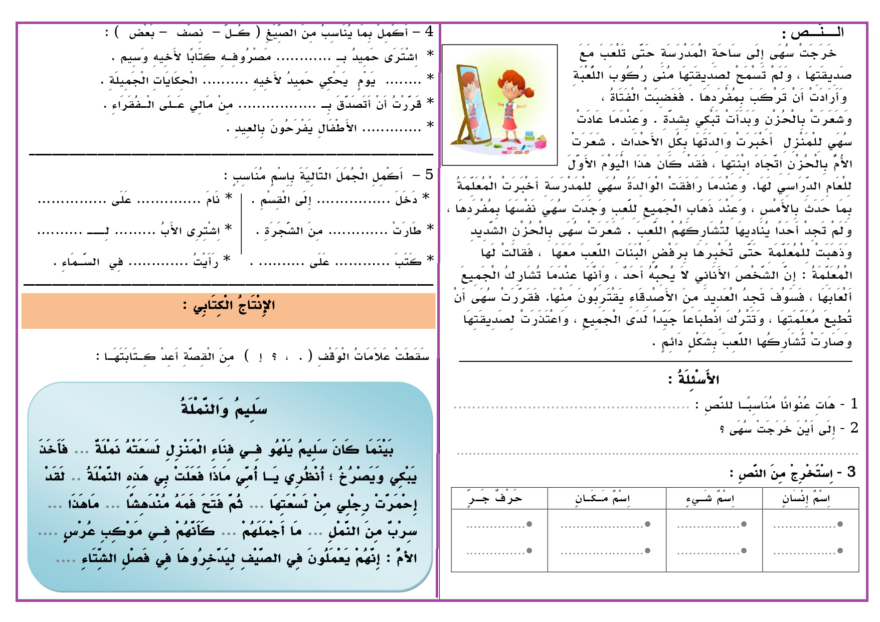

|  |  |  |  |  |  |  |  |  |  |  |  |  |  |  |  |  |  |  |  |  |  |  |  |  |  |  |  |  |  |  |  |  |  |  |  |  |  |  |  |  |  |  |  |  |  |  |  |  |  |  |  |  |  |  |  |  |  |  |  |  |  |  |  |  |  |  |  |  |  |
| --- | --- | --- | --- | --- | --- | --- | --- | --- | --- | --- | --- | --- | --- | --- | --- | --- | --- | --- | --- | --- | --- | --- | --- | --- | --- | --- | --- | --- | --- | --- | --- | --- | --- | --- | --- | --- | --- | --- | --- | --- | --- | --- | --- | --- | --- | --- | --- | --- | --- | --- | --- | --- | --- | --- | --- | --- | --- | --- | --- | --- | --- | --- | --- | --- | --- | --- | --- | --- | --- |
| 1. **أُكْتُبْ الأَعْدَادَ التَّالِيَّةَ بِالأَرْقَامِ :**  |  |  |  |  |  | | --- | --- | --- | --- | --- | | **خَمْسُ مَائَةٍ و ثَلاَثَةٌ وَخَمْسُونَ** | ........ |  | **ثَمَانُ مَائَةٍ وَ تِسْعَةٌ** | ....... | | **تِسْعُ مَائَةٍ وَ أَرْبَعُونَ** | ........ | **مِئَتَانِ وَثَلاَثَةٌ وَعِشْرُونَ** | ....... |  1. **أُكْتُبْ الْأَعْدَادَ التَّالِيَّةَ بِالْحُرُوفِ :**  |  |  |  |  |  | | --- | --- | --- | --- | --- | | **733** | ........................................... |  | **410** | ........................................ | | **651** | ........................................... | **319** | ......................................... |   **3 – أُرُتِبُ الْأَعْدادَ التَّالِيَةَ مِنَ الْأَكْبَرِ إِلَى الْأَصْغَرِ :**  **892 - 392 – 751 – 569 – 288 - 286 – 393**   |  |  |  |  |  |  |  | | --- | --- | --- | --- | --- | --- | --- | | ......... | ......... | ........... | ........ | ........... | ......... | .......... |   **4 - أُرُتِبُ الْأَعْدادَ التَّالِيَةَ مِنَ الْأَصْغَرِ إِلَى الْأَكْبَرِ:**  **58 7 – 862 - 920 – 493 – 614 – 232 – 917**   |  |  |  |  |  |  |  | | --- | --- | --- | --- | --- | --- | --- | | ......... | ......... | ........... | ........ | ........... | ......... | .......... |   5 – **أُلَاحِظُ الْجَدْوَلَ ثُمَّ أَكْمِلُ :**   |  |  |  |  |  | | --- | --- | --- | --- | --- | | **الْعَدَدُ** | **رْقْمُ الْوَحَدَاتِ** | **رَقْمُ الْعَشَرَاتِ** | **رَقْمُ الْمِئَاتِ** | **الــتَّــفْــكِــيـــكُ** | | **733** | ...... | ......... | **......** | **3+30 + 700 = 733** | | **215** | ............ | .......... | **.....** | **...+.... + .... = .....** | | ........ | **6** | **4** | **1** | **...+.... + .... = .....** | | ......... | ............. | ....... | **......** | **...+.... + .... = 391** |   **6** **– أُكْمِلُ بِالْعَدَدِ الْمُنَاسِبِ :**   |  |  |  | | --- | --- | --- | | **100 + 530 = …….**  **10 + 350 = …….** | **100** - **530 = …….**  **10** - **350 = ……** | **......... + 683 = 693**  **........ + 429 = 529** | | **7 – أَكْمِلْ مَلْءَ الفَرَاغِ بِمَا يُنَاسِبُ بِحَسَبِ الْمِثَالَيْنِ :**    **\*\* العدد 574 هو : 5 مِئَاتٍ و 7 عَشَرَاتٍ وَ 4 وَحَدَاتٍ**  **\* الْعَدَدُ 653 هُوَ : ...... مِئَاتٍ وَ ....... عَشَرَاتٍ وَ ...... وَحَدَاتٍ**  **\* الْعَدَدُ 438 هُوَ : ...... مِئَاتٍ وَ ....... عَشَرَاتٍ وَ ...... وَحَدَاتٍ**  **\* الْعَدَدُ 501 هُوَ : ...... مِئَاتٍ وَ ....... عَشَرَاتٍ وَ ...... وَحَدَاتٍ**  **\*\* 8 مِئَاتٍ و 6 عَشَرَاتٍ وَ 9 وَحَدَاتٍ هُوَ الْعَدَدُ 869**  **\* 4 مِئَاتٍ و 7 عَشَرَاتٍ وَ 3 وَحَدَاتٍ هُوَ الْعَدَدُ ........**  **\* مَــائَةٌ و 4 عَشَرَاتٍ وَ 4 وَحَدَاتٍ هُوَ الْعَدَدُ ..........**  **\* 9 مِئَاتٍ و عَشَرَتَانِ وَ 5 وَحَدَاتٍ هُوَ الْعَدَدُ .........**  **8 – أَلاَحِظُ ثُمَّ أُكْمِلُ مَلْءَ الفَرَاغِ بِكِتَابَةِ الْعَدَدِ بِالأَرْقَامِ وَالْحُرُوفِ :**   |  |  | | --- | --- | |  | | | **...........................................** | **............................................** |  |  |  |  | | --- | --- | --- | | **100 + 693 = …….**  **10 + 915 = …….** | **...... - 33 = 32**  **..... - 298 = 198** | **......... + 504 = 604**  **........ + 359 = 459** |   **9– أُنْجِزُ الْعَمَلِيَاتِ الحِسَابِيَّةِ التَّالِيَةِ :**   |  | | --- | | **ملاحظة : يَتِمُ تَوْجِيهُ التَّلَامِيذِ نَحْوَ الْحَلِ وَالتَّبْسِيطِ لَهُمْ وَلَيْسَ الِإنْجَازِ لَهُم مَعَ اِسْتِعْمَالِ اللَّوْحَةِ لِلْمُحَاوَلَةِ .** | |